Nutritional Consulting Intake Form

Client Name:
Date:
Address:

How would you describe your overall current health?

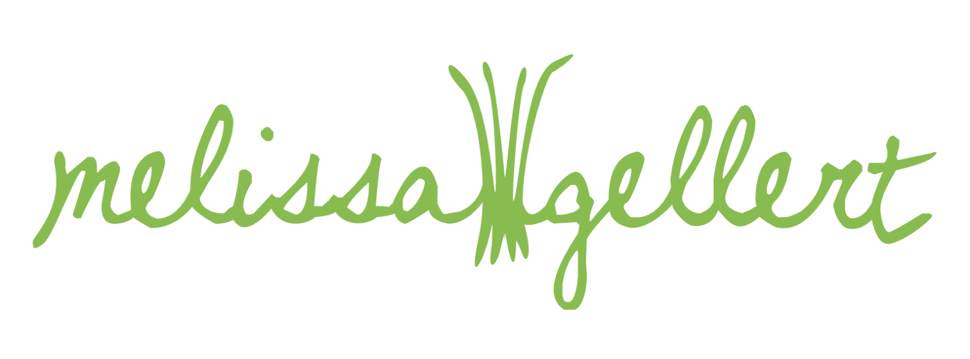
What would it be like to feel better? Describe your attitude, your surroundings, how your body feels, and how others would treat you.

What conditions have you been diagnosed with?

Have you recently undergone any surgery or medical procedures?

How long have you been receiving treatment for these conditions? What is the treatment?

What medications are you currently taking?

Are you taking any other vitamins/supplements? Please list!

What recommendations have your health professionals made regarding diet and supplements?

Describe your image of perfect health, and what that means to you.

Do you need to make any significant dietary changes or transitions?
(Eliminating sugar, reducing caffeine, cutting down on red meat, etc.)

How long would you like to give yourself to make those changes?

How long have you had, or been aware of, your food sensitivities?

What are your restrictions? What are your food allergies?

Will I be providing meal plans/recipes/inspirations just for you, or for other members of the family as well? (Please include each persons food restrictions/preferences.)

What foods do you LOVE?

What foods do you HATE?

What foods do you feel MEH about?

What cuisines are your favorite? Italian? Indian?

If you didn't have ANY dietary restrictions, what meal would you
indulge in? (Feel free to be extravagant here! This helps me create
food hacks for you and incorporate things that push your pleasure
buttons without popping your buttons.)

Do you need inspiration for breakfast, lunch, dinner, and two snacks a
day? Or just lunch and dinner?

Any other information you’d like to share?

